1. **NAME OF SCHOOL**

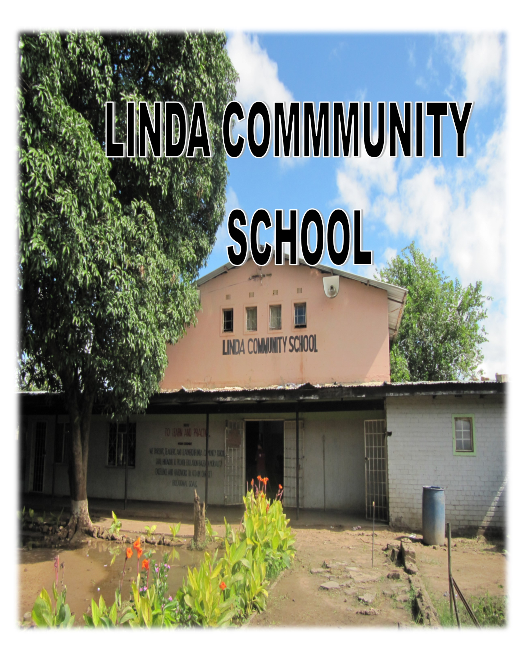

**2. TABLE OF CONTENT**

1. **NAME OF SCHOOL ……………………………………………………………………………………………….. 1**
2. **TIME OF CONTENT……………………………………………………………………………………………….. 2**
3. **HISTORY ……………………………………………………………………………............................................... 3**
4. **LOCATION………………………………………………………………………………....................................... 4**
5. **PUPIL ENROLMENT AND STAFFING ………………………………………………………………………….. 5**
6. **WHAT NECESSITATED TO HAVE A SCHOOL IN THE AREA………………………………………………. 6**
7. **WHO WAS INFLUENTIAL IN INITIATING THE SCHOOL …………………………………………………… 6**
8. **WHICH DID THE SCHOOL OPEN ………………………………………………………………………………… 6**
9. **TYPE OF STRUCTURE USED AT START OF THE SCHOOL …………………………………………………. 6**
10. **WHO WAS THE HEAD AT THE OPENING OF THE SCHOOL AND HEADTEACHERS THEREAFTER….6**
11. **WHAT IMPROVEMENTS HAVE BEEN MADE AND WHICH PERIOD ……………………………………… 7**
12. **CURRENT PUPIL PERFORMANCE …………………………………………………………………………………8**
13. **REFLECTION AND HOW YOU INTEND TO IMPROVE THE GENERAL OUTLOOK ………………… 9- 10**
14. **WHAT DO YOU NEED IF THIS IMPROVEMENT HAS TO TAKE PLACE & SUSTAINED** ……………. 10

**3. HISTORY**

Linda community school was founded on 14th October 1996. The school was one of the projects that were being run by the Livingstone street children association (LISCA School). The school was as an intervention measures for the former street children and a prevention measure for the children at risk to go to the street. The school works with orphans, children in conflict with the law , HIV positive children and street children. The first priority is given to double orphans meaning both parents are dead , second priority is given to single orphans and 5% to vulnerable with both parents, mostly from young parents , too old parents , disabled parents and sick parent (chronically ill.

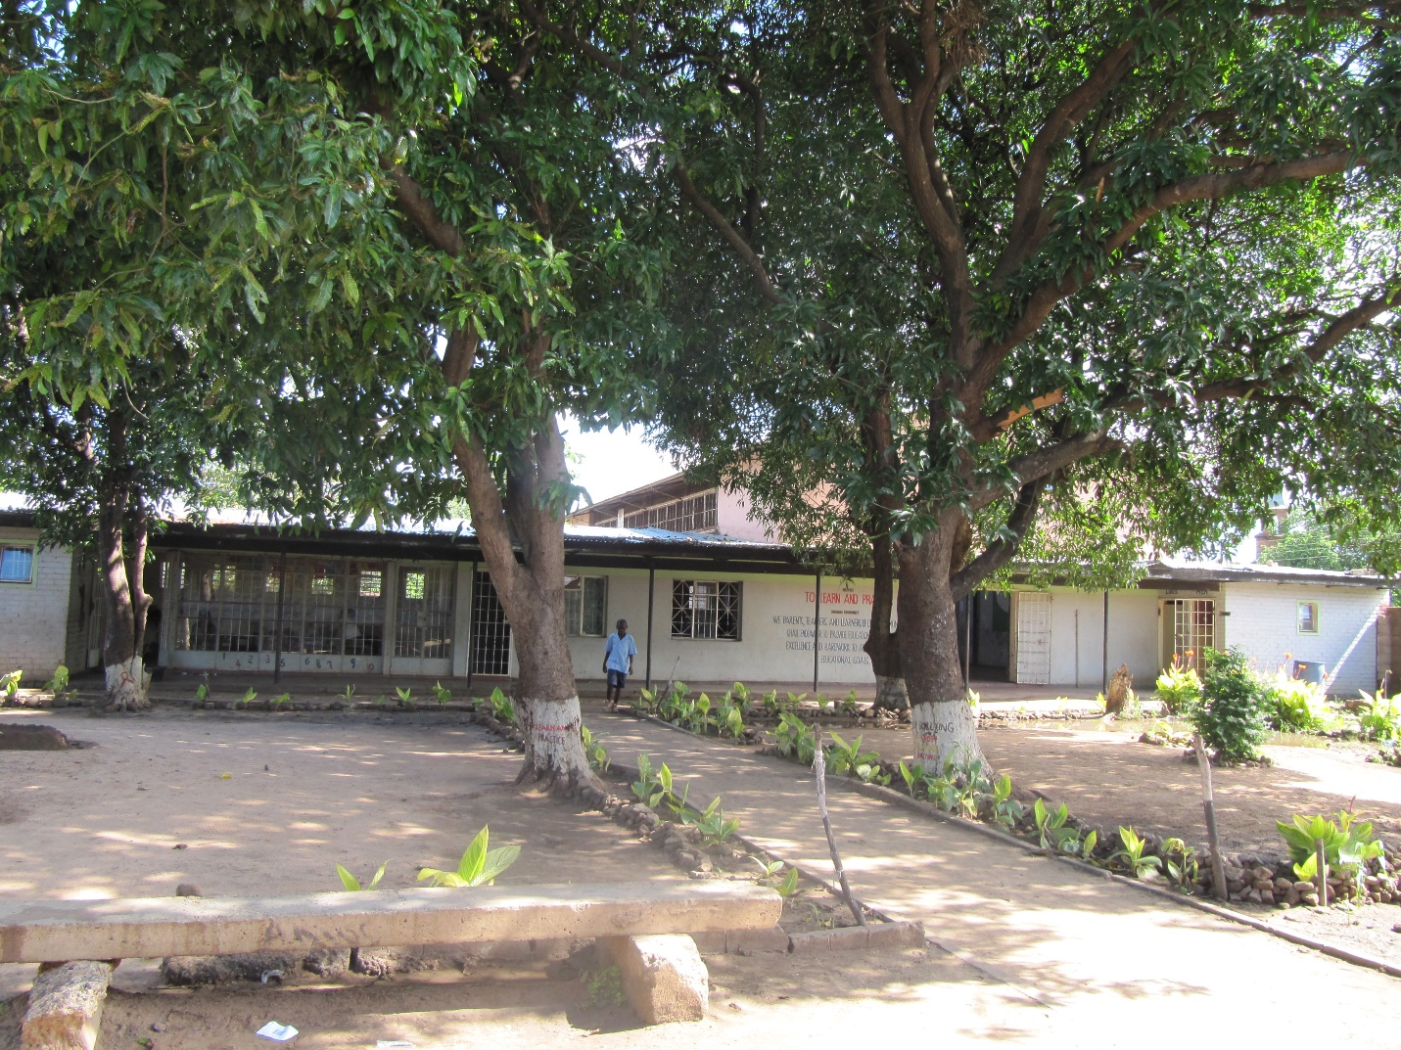

**4. LOCATION**

Linda community school is located in Livingstone district in southern province of Zambia. It lies to the south of the city that is in Nansanzu zone Linda Township about 3 kilometers from the city and the DEBS office.

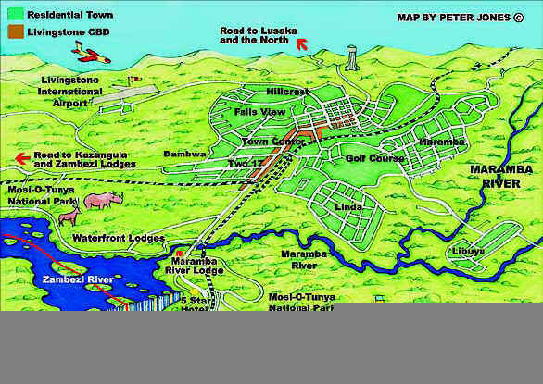

**5. PUPIL ENROLMENT AND STAFFING**

**PUPIL ENROLMENT**

The school has to the total number of 470 pupils, meaning 241 boys and 229

|  |  |  |
| --- | --- | --- |
| **GRADE** | **NO. OF BOYS** | **NO. OF BOYS** |
| 1 (one) | 30 | 23 |
| 2 (two) | 37 | 33 |
| 3 (three) | 38 | 37 |
| 4 (four) | 28 | 32 |
| 5 (five) | 43 | 39 |
| 6 (six) | 32 | 33 |
| 7 (seven) | 33 | 37 |
| **Total** | **241** | **234** |
| **Total enrolment 475** | | |

**STAFFING**

The school has three male teachers and 5 female, making the total number of staffing to 8 members of staff.

|  |  |  |  |
| --- | --- | --- | --- |
| **NO.** | **NAME** | **SEX** | **POSITION** |
|  | CHILAMBE CATHY | F | HEAD TEACHER |
|  | NDLOVU JOEY | M | DEPUTY HEAD |
|  | DAKA MALINDI PRISCAR | F | SENIOR TEACHER |
|  | MVULA MWANGA MATILDAH | F | CLASS TEACHER |
|  | MUDENDA NELIA | F | CLASS TEACHER |
|  | CHISANGA ZACHARIA | M | CLASS TEACHER |
|  | ESTER | F | CLASS TEACHER |
|  | DAKA SYDNEY | M | CLASS TEACHER |

**6. What necessitated to have a school in the area?**

* The school was mainly established to give a home to the street children.
* To provide education to the street children and orphans.
* Retain learners especially girls.
* Help the vulnerable children access education in the community
* Provide Community service, the school has other activities which include:
* Paying school fees for poor children
* Carrying health or HIV/AIDS messages through songs and drama
* Participating in community celebrations and games

**7. Who influential in initiating the starting of the school?**

Ms. Chilambe Cathy

Mr. Chewe Smoke

Mr. Nkumba Timothy

Mr. Muhongo Alvin

Mrs. Habwacha Isabel

**8. Type of school structure.**

* The school is currently using the Linda council building

1. **The head at opening.**

The head teachers of the community school were at first called school supervisors the school from the time it stated.

|  |  |  |  |
| --- | --- | --- | --- |
| **NO.** | **NAME** | **FROM** | **TO** |
|  | Ms. Chilambe Cathy | 1996 | 2018 |
|  |  |  |  |

1. **What improvement has been done since?**

The school has made improvements ever since it was open which are as follows:

1. ***the school makes its on reading materials, which as attributed to***

* increased reading and writing skills among the leaners
* improve comprehension skills to the learners
* increased pupils ‘s vocabulary
* improved reading and writing skills;

1. ***the has its own examination centre***

* school has grown up to grade seven and
* the pass rate has improved from 70% to 98%, dues to the introduction of science circus and making of story books.

1. ***the school acquired a school plots for the development of the school***
2. ***the school has trained teaches***
3. ***improved science skills because of the science circus programme***
4. ***Able to retain learners especially girls due to girls impact club. Zero pregnancy in the past 5 years due to the same programme***
5. **CURRENT PUPIL PERFORMANCE**

|  |  |  |  |  |
| --- | --- | --- | --- | --- |
| **YEAR** | **PUPILS** | **MALE** | **FEMALE** | **TOTAL** |
| **2005** | SAT | 13 | 9 | **22** |
| ACCEPTED | 6 | 5 | **11** |
| - | - | - | **-** |
| - | - | - | **-** |
| **2006** | SAT | 15 | 9 | **24** |
| ACCEPTED | 12 | 6 | **18** |
| - | - | - | **-** |
| **2008** | SAT | 17 | 5 | **22** |
| ACCEPTED | 16 | 4 | **20** |
|  |  |  |  |
| **2009** | SAT | 12 | 12 | **24** |
| ACCEPTED | 9 | 11 | **20** |
|  |  |  |  |
| **2010** | SAT | 18 | 7 | **25** |
| ACCEPTED | 15 | 5 | **20** |
|  | - | - | **-** |
| **2011** | SAT | 18 | 9 | **27** |
| ACCEPTED | 17 | 7 | **24** |
| HIGH SCORE | 712 | 664 | **-** |
|  | LOWEST SCORE | 520 | 541 |  |
| CUT OFF | 550 | 550 |  |
| **2012** | SAT | 15 | 14 | **29** |
| ACCEPTED | 15 | 14 | **29** |
| HIGH SCORE | 687 | 668 | **-** |
| LOWEST SCORE | 520 | 512 | **-** |
| CUT OFF | 500 | 500 | **-** |
| **2013** | SAT | 16 | 14 | **30** |
| ACCEPTED | 15 | 14 | **29** |
| HIGHEST SCORE | 700 | 715 | **-** |
| LOWEST SCORE | 468 | 500 | **-** |
| **2014** | SAT | 19 | 15 | **34** |
| ACCEPTED | 19 | 15 | **34** |
| HIGHEST SCORE | 716 | 718 | **-** |
| LOWEST SCORE | 517 | 502 | **-** |
| **2015** | SAT | 23 | 18 | **41** |
| ACCEPTED | 14 | 10 | **28** |
| FAILED | 9 | 8 | **17** |
| HIGHEST SCORE | 718 | 705 | **-** |
| LOWEST SCORE | 495 | 424 | **-** |
| ABSENTEES | 2 | 2 | **4** |
| **2016** | SAT | 25 | 19 | **44** |
| ACCEPTED | 20 | 15 | **35** |
| FAILED | 5 | 4 | **9** |
| HIGHEST SCORE | 714 | 752 |  |
| LOWEST SCORE | 611 | 601 |  |
| CUT OFF | 600 | 600 |  |
| **2017** | SAT | 30 | 34 | **64** |
| ACCEPTED | 20 | 28 | **28** |
| FAILED | 10 | 6 | **16** |
| HIGHEST SCORE | 740 | 760 |  |
|  | LOWEST SCORE | 500 | 506 |  |
| CUT OFF | 600 | 600 |  |

1. **How to improve the general outlook and performance of leaners**
2. encourage remedial work

* The slow learners should usually be given remedial work as part of a catch up plan.

1. Introduce math games

* Children can work independently of the teacher. The rules of the game and the children’s motivation usually keep them on task.

1. Integrate ICT in the teaching and learning
2. Increase on the implementation of homework policy

**CHALLENGES**

* The school is facing many challenges one of which is lack of room to accommodate teachers to decongest the staff room which is small and serves as a store room.
* Inadequate teaching and learning materials to cater for all teachers as well as pupils.
* The other challenge is the behavior of most of the learners and late coming.
* Lack of classes
* Limited teaching and learning materials
* No computer lessons

1. **What do you need if this improvement has to take place and sustained**

* Build a school from grade 1 to 12 because most of our children drop out as they reach secondary due to failure to pay school fees.
* Support the untrained teachers for teacher training
* Intensify in-service training for all teacher in Mathematics and science
* Integrate ICT in teaching and learning

**WAY FORWARD**

Some of the challenges that the school is facing like inadequate books can be solved with the help of parents through the Parent-Teacher Association, the government and other well wishes. Indiscipline and bad behavior can only be overcome through the teaching of Religious Education to all classes and giving guidance to the learner and also through parents and teachers’ interactions. Late coming can only be overcome by putting stiff punishment for those pupils who come late, if possible the gates be closed and closely monitored when time is up.